Assignment 1
Input:
#include <stdlib.h>
#include <stdio.h>

void accept(int a[10][10], int m, int n)
{
int i, j;
printf("\nEnter matrix elements:");
for (i=0; i<m; i++)
{
for (j=0; j<n; j++)
{
scanf("%d", &a[i][j]);

}
}
}

void display(int a[10][10], int m, int n)
{
int i, j;
for (i=0; i<m; i++)
{
for (j=0; j<n; j++)
{
printf("\t%d", a[i][j]);

}
printf("\n");
}
}

void add(int a[10][10], int b[10][10], int m, int n)
{
int c[10][10], i, j;
for (i=0; i<m; i++)
{
for (j=0; j<n; j++)
{
c[i][j]= a[i][j]+ b[i][j];

}
}
printf("\nAddition of Matrices:\n");
display(c, m, n);
}

void sub(int a[10][10], int b[10][10], int m, int n)
{
int d[10][10], i, j;
for (i=0; i<m; i++)
{
for (j=0; j<n; j++)
{
d[i][j]= a[i][j]- b[i][j];
}
}
printf("\nSubtraction of Matrices:\n");
display(d, m, n);
}

void mult(int a[10][10], int b[10][10], int m, int n)
{
int e[10][10], i, j, k;
for (i=0; i<m; i++)
{
for (j=0; j<n; j++)
{
e[i][j]= 0;
for (k=0; k<n; k++)
{
e[i][j]+= a[i][k]* b[k][j];
}
}
}
printf("\nMultiplication of Matrices: \n");
display(e, m, n);
}

void trans(int a[10][10], int m, int n)
{
int t[10][10], i, j;
for (i=0; i<m; i++)
{
for (j=0; j<n; j++)
{
t[j][i]= a[i][j];

}
}
printf("\nTranspose of Matrix: \n");
display(t, m, n);
}

int main()
{
int a[10][10], b[10][10];
int m, n, ch;

printf("Enter number of rows and columns: ");
scanf("%d %d", &m, &n);

printf("\nEnter first matrix: \n");
accept(a, m, n);

printf("\nEnter second matrix: \n");
accept(b, m, n);

do
{
printf("\nMenu: \n\n1. Addition \n2. Subtraction \n3. Multiplication \n4. Transpose \n5. Display Matrices \n6. Exit\n");
printf("\nEnter choice: ");
scanf("%d", &ch);

switch (ch)
{
case 1:
add(a, b, m, n);
break;

case 2:
sub(a, b, m, n);
break;

case 3:
if (m==n)
mult(a, b, m, n);
else
printf("\nEnter a square matrix\n");
break;

case 4:
trans(a, m, n);
break;

case 5:
printf("\nFirst Matrix: \n");
display(a, m, n);
printf("\nSecond Matrix: \n");
display(b, m, n);
break;

case 6:
break;

default:
printf("\nInvalid choice\n");

}
} while (ch != 6);
return 0;
}

Output:
Enter number of rows and columns: 3 3

Enter first matrix:

Enter matrix elements:
4 2 6
7 2 2
5 6 2

Enter second matrix:

Enter matrix elements:
1 1 8
7 5 0
0 2 6

Menu:

1. Addition
2. Subtraction
3. Multiplication
4. Transpose
5. Display Matrices
6. Exit

Enter choice: 1

Addition of Matrices:
5 3 14
14 7 2
5 8 8

Menu:

1. Addition
2. Subtraction
3. Multiplication
4. Transpose
5. Display Matrices
6. Exit

Enter choice: 2

Subtraction of Matrices:
3 1 -2
0 -3 2
5 4 -4

Menu:

1. Addition
2. Subtraction
3. Multiplication
4. Transpose
5. Display Matrices
6. Exit

Enter choice: 3

Multiplication of Matrices:
18 26 68
21 21 68
47 39 52

Menu:

1. Addition
2. Subtraction
3. Multiplication
4. Transpose
5. Display Matrices
6. Exit

Enter choice: 4

Transpose of Matrix:
4 7 5
2 2 6
6 2 2

Menu:

1. Addition
2. Subtraction
3. Multiplication
4. Transpose
5. Display Matrices
6. Exit

Enter choice: 5

First Matrix:
4 2 6
7 2 2
5 6 2

Second Matrix:
1 1 8
7 5 0
0 2 6

Menu:

1. Addition
2. Subtraction
3. Multiplication
4. Transpose
5. Display Matrices
6. Exit

Enter choice: 6

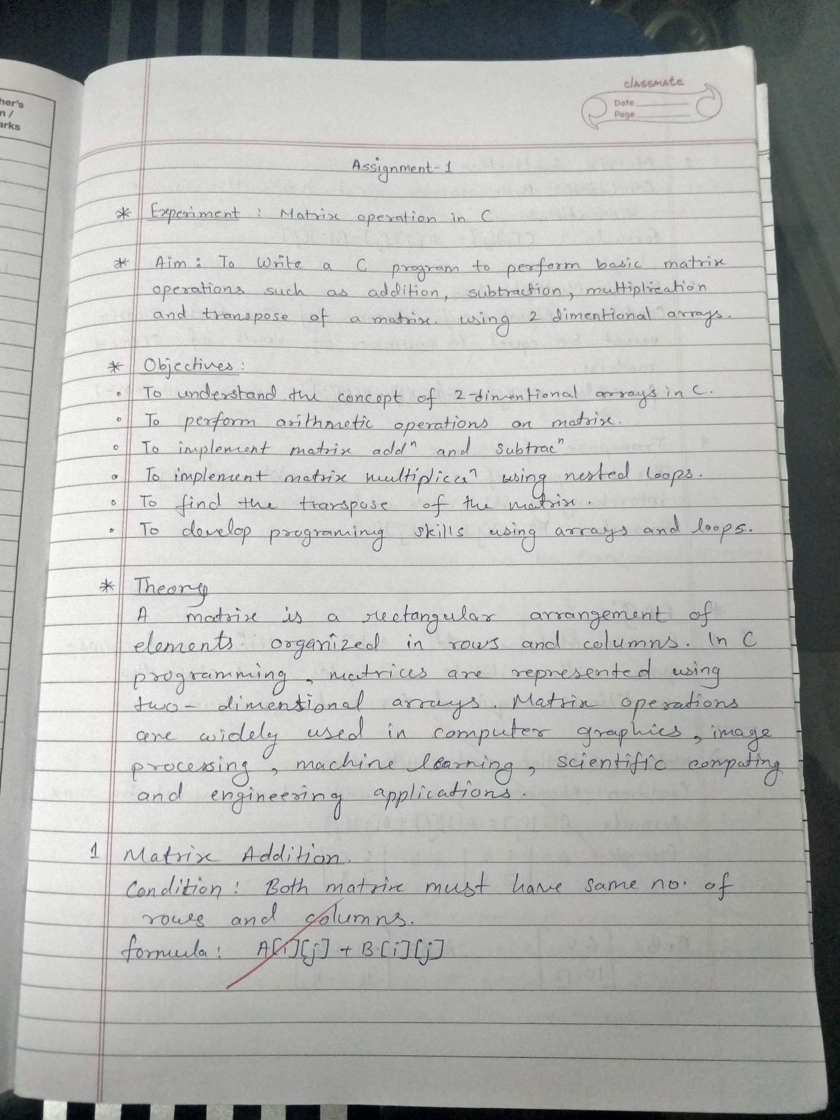
=== Code Execution Successful ==

